

**Green University of Bangladesh**

**Department of Computer Science and Engineering (CSE)**

**Faculty of Sciences and Engineering**

**Semester: (Fall, Year:2024, B.Sc. in CSE (Day)**

**Lab Report NO #09**

**Course Title: Mobile Application Development**

**Course Code: CSE-426 Section: 213 D-3**

**Lab Experiment Name: Update and Delete operations on the database.**

**Student Details**

|  |  |  |
| --- | --- | --- |
| **Name** | | **ID** |
| **1.** | Nadib Rana | 213002247 |

**Lab Date : 09.12.2024**

**Submission Date : 16.12.2024**

**Course Teacher’s Name** **: Md. Jahid Tanvir**

|  |
| --- |
| **Lab Report Status**  **Marks: ………………………………… Signature:.....................**  **Comments:.............................................. Date:..............................** |

**1.TITLE OF THE LAB REPORT EXPERIMENT**

Implement Update and Delete operations on the database.

**2. OBJECTIVES**

* To understand the SQL lite database.
* To understand Update and Delete operation.

**4. PROCEDURE**

**mainActivity.java**

package com.example.something;  
  
import androidx.appcompat.app.AppCompatActivity;  
import android.database.Cursor;  
import android.database.sqlite.SQLiteDatabase;  
import android.os.Bundle;  
import android.view.View;  
import android.widget.Button;  
import android.widget.EditText;  
import android.widget.TextView;  
import android.widget.Toast;  
  
public class MainActivity extends AppCompatActivity {  
 EditText ename, ecollege;  
 Button binsert, bupdate, bdelete, bdisplay;  
 TextView displayData;  
 SQLiteDatabase db;  
  
 @Override  
 protected void onCreate(Bundle savedInstanceState) {  
 super.onCreate(savedInstanceState);  
 setContentView(R.layout.*activity_main*);  
  
 // Initialize UI components  
 ename = findViewById(R.id.*ename*);  
 ecollege = findViewById(R.id.*ecollege*);  
 binsert = findViewById(R.id.*binsert*);  
 bupdate = findViewById(R.id.*bupdate*);  
 bdelete = findViewById(R.id.*bdelete*);  
 bdisplay = findViewById(R.id.bdisplay);  
 displayData = findViewById(R.id.displayData);  
  
 // Open or create database  
 db = openOrCreateDatabase("Mydb", *MODE_PRIVATE*, null);  
 db.execSQL("CREATE TABLE IF NOT EXISTS student(name VARCHAR, college VARCHAR);");  
  
 // Insert operation  
 binsert.setOnClickListener(new View.OnClickListener() {  
 @Override  
 public void onClick(View v) {  
 String name = ename.getText().toString();  
 String college = ecollege.getText().toString();  
  
 if (!name.isEmpty() && !college.isEmpty()) {  
 db.execSQL("INSERT INTO student VALUES('" + name + "', '" + college + "');");  
 Toast.*makeText*(getApplicationContext(), "Row Inserted", Toast.*LENGTH_SHORT*).show();  
 clearFields();  
 } else {  
 Toast.*makeText*(getApplicationContext(), "Please enter all details", Toast.*LENGTH_SHORT*).show();  
 }  
 }  
 });  
  
 // Update operation  
 bupdate.setOnClickListener(new View.OnClickListener() {  
 @Override  
 public void onClick(View v) {  
 String name = ename.getText().toString();  
 String college = ecollege.getText().toString();  
  
 if (!name.isEmpty() && !college.isEmpty()) {  
 db.execSQL("UPDATE student SET college = '" + college + "' WHERE name = '" + name + "';");  
 Toast.*makeText*(getApplicationContext(), "Row Updated", Toast.*LENGTH_SHORT*).show();  
 clearFields();  
 } else {  
 Toast.*makeText*(getApplicationContext(), "Please enter all details", Toast.*LENGTH_SHORT*).show();  
 }  
 }  
 });  
  
 // Delete operation  
 bdelete.setOnClickListener(new View.OnClickListener() {  
 @Override  
 public void onClick(View v) {  
 String name = ename.getText().toString();  
  
 if (!name.isEmpty()) {  
 db.execSQL("DELETE FROM student WHERE name = '" + name + "';");  
 Toast.*makeText*(getApplicationContext(), "Row Deleted", Toast.*LENGTH_SHORT*).show();  
 clearFields();  
 } else {  
 Toast.*makeText*(getApplicationContext(), "Please enter the name to delete", Toast.*LENGTH_SHORT*).show();  
 }  
 }  
 });  
  
 // Display operation  
 bdisplay.setOnClickListener(new View.OnClickListener() {  
 @Override  
 public void onClick(View v) {  
 Cursor cursor = db.rawQuery("SELECT * FROM student", null);  
 if (cursor.getCount() > 0) {  
 StringBuilder sb = new StringBuilder();  
 while (cursor.moveToNext()) {  
 sb.append("Name: ").append(cursor.getString(0)).append("\n");  
 sb.append("College: ").append(cursor.getString(1)).append("\n\n");  
 }  
 displayData.setText(sb.toString());  
 } else {  
 displayData.setText("No Data Found");  
 }  
 }  
 });  
 }  
  
 // Helper method to clear input fields  
 private void clearFields() {  
 ename.setText("");  
 ecollege.setText("");  
 }  
}

**mainActivity.xml**

<?xml version="1.0" encoding="utf-8"?>  
<LinearLayout  
 xmlns:android="http://schemas.android.com/apk/res/android"  
 android:layout_width="match_parent"  
 android:layout_height="match_parent"  
 android:orientation="vertical"  
 android:padding="16dp">  
  
 <!-- Name Input -->  
 <EditText  
 android:id="@+id/ename"  
 android:layout_width="match_parent"  
 android:layout_height="wrap_content"  
 android:hint="Enter Name"  
 android:layout_marginBottom="8dp"/>  
  
 <!-- College Input -->  
 <EditText  
 android:id="@+id/ecollege"  
 android:layout_width="match_parent"  
 android:layout_height="wrap_content"  
 android:hint="Enter College"  
 android:layout_marginBottom="8dp"/>  
  
 <!-- Buttons -->  
 <Button  
 android:id="@+id/binsert"  
 android:layout_width="match_parent"  
 android:layout_height="wrap_content"  
 android:text="Insert"  
 android:layout_marginBottom="8dp"/>  
  
 <Button  
 android:id="@+id/bupdate"  
 android:layout_width="match_parent"  
 android:layout_height="wrap_content"  
 android:text="Update"  
 android:layout_marginBottom="8dp"/>  
  
 <Button  
 android:id="@+id/bdelete"  
 android:layout_width="match_parent"  
 android:layout_height="wrap_content"  
 android:text="Delete"  
 android:layout_marginBottom="8dp"/>  
  
 <Button  
 android:id="@+id/bdisplay"  
 android:layout_width="match_parent"  
 android:layout_height="wrap_content"  
 android:text="Display"  
 android:layout_marginBottom="8dp"/>  
  
 <!-- Display Area -->  
 <TextView  
 android:id="@+id/displayData"  
 android:layout_width="match_parent"  
 android:layout_height="wrap_content"  
 android:text="No Data Found"  
 android:textSize="16sp"  
 android:layout_marginTop="16dp"/>  
</LinearLayout>

**OUTPUT:**

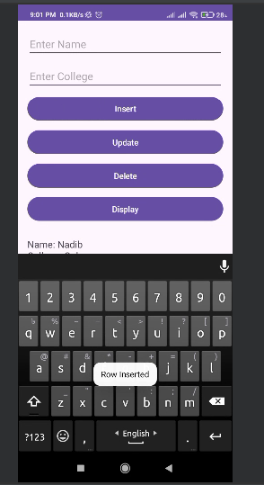 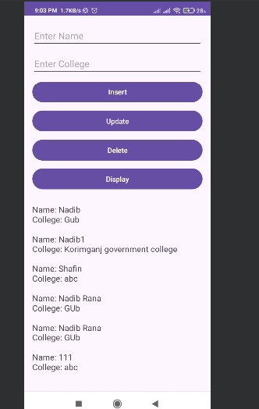 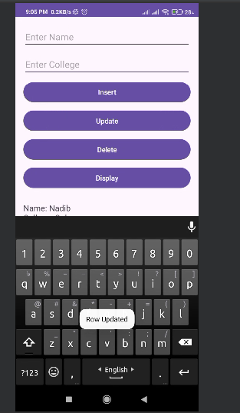 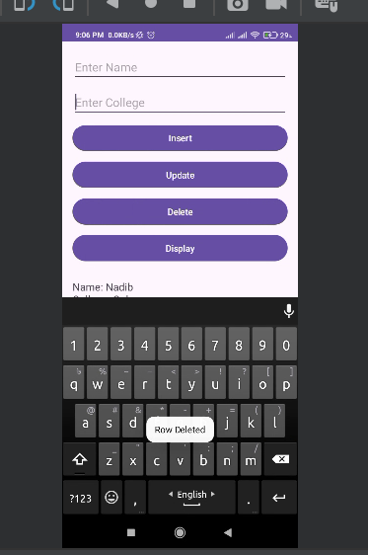

**Overview:**

